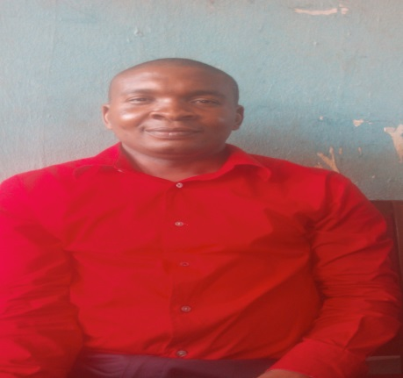

Name: Dr. Ossai, Osita Victor
Department: Educational Foundations
Faculty: Education
Designation: Lecturer II
E-mail: osita.ossai@unn.edu.ng
PhoneNumber: 08064879668

Biography:
Dr.Ossai, Ositawas born on the 18th day of June 1985 at Igogoro Igbo Eze North Local Government Area of Enugu State. He attended Central School, Igogoro, Enugu Ezike between 1991-1996; St.Teresa’sCollege,Nsukka between 1996- 2002; University of Nigeria, Nsukka between 2004-2008 where he obtained his first degree. For his post graduate programme he continued at the University of Nigeria, Nsukka where he obtained a Masters Degree and PhD in Educational Psychology between 2009-2012 and 2013-2016 respectively. He has contributed many articles in both local and international journals. His researchinterest on human learning and Gender-based research.

Area of specialization: Educational Psychology

Membership of Professional Bodies:
Nigerian Council of Educational Psychologists (NCEP)

Research interest: Human Learning and Gender-Based Research

Responsibilities:
- Member, Publications Committee, Department of Educational Foundations, University of Nigeria, Nsukka.
- Teaching and grading of the following courses:
Undergraduate Courses:EDU 211, EDU 312, EDU 411.
PGDE Courses: EDU 0511, EDU O512, EDU 0514.
M.ED Courses: EDU 515, EDU 515^{A}

- PGDE and M.ED supervision

Research archives:
Conferences Attended and Papers Presented
- Ngwoke, D.U.; Ossai, O.V.; Idoko, E, J; Obikwelu, C.L. (2016).Impact of Gender Orientation on Entrepreneurial Self-efficacy of University Undergraduates in Enugu State, Nigeria. Paper presented at the Annual National Conference of Nigeria Council of Educational Psychologists (NCEP) held at ESUT Auditorium on 9th-11th September, 2016.

- Ossai, O.V; Ezurike, C.A. (2017). Parental Support and Socio-cultural Belief as Predictors of School Enrolment of Upper Basic Students in Nsukka Urban Area of Enugu State, Nigeria. Paper Presented at the Annual National Conference of Nigerian Council of Educational Psychologists (NCEP) held at Multi-Purpose Hall, University of Abuja on 17th-21stOctober, 2017.

EDUCATIONAL INSTITUTIONS ATTENDED WITH DATES

University of Nigeria, Nsukka.
Ph.D Educational Psychology 2013-2016

University of Nigeria, Nsukka.
M.Ed. in Educational Psychology 2009- 2012

University of Nigeria, Nsukka.
B.A(Ed) in Education English 2004-2008

National Youth Service Corp
NYSC Discharge Certificate 2009-2010

UNN/AFRIHUB ICT Centre
Certificate in Computer Studies & Operations 2007-2008

St.Teresa’sCollege,Nsukka
Senior Secondary Certificate Examination 1996-2002

CentralSchool, Igogoro Enugu Ezike
Primary School Leaving Certificate 1991-1996

Journal Publications
Dr. Ossai, Osita Victor

- Victor-Agbodion, V; Ossai, O.V &Nicholas, C.M.(2018).Academic adjustment as Correlate of School Attendance among In-school Adolescents in Edo State. Journal of Nigeria Academy of Education.32(1)

- Ononaiwu, A.I; Ossai, O.V;& Victor-Agbodion, V. (2018). Effects of Cognitive Restructuring on Mathematics Achievement Orientation among Senior Secondary School Students. Journal of Nigeria Academy of Education.32(1)

- Eze, P.O, Victor-Aigbodion, V, Ossai O.V,Ugwoezuonu A.U, Egenti N.T, &Eseadi C. (2017). Procedures for the Construction and Development of Psychological Test. European Journal of Scientific Research, 145(2) 146-151.

- Eseadi, C.; Ezurike, C.A.; Obidoa,M.A;Ossai, O.V. (2017). Effect of Rational Emotive Behavior Therapy on Re-Offending Thoughts of Nigerian Prison Inmates. The Educational Psychologist.11(1)267-275

- Ngwoke, D. U.; Ossai, O.V; Obikwelu, C. L.Idoko, E. J. O.(2017). Impact of Gender Orientation on Entrepreneurial Self-efficacy of University Undergraduates in Enugu State, Nigeria.The Educational Psychologist.11(1) 219-226

- Ogwuche, O. C; Adikwu, V.O; Ossai, O.V (2017).Gender Stereotype and Women Empowerment in Nigeria: The Need for a Paradigm Shift in Role of Counsellors and School Psychologists. The Educational Psychologist.11(1)165-171

- Ngwoke,D.U.; Ossai,O.V.; Ngwoke, A.N.; Eskay, M (2013). Influence of study skills on the academic Achievement of senior secondary school students in Nsukka Urban Area of Enugu State. Indian Streams Research Journal 3(8)

- Ngwoke, D.U.; Ossai, O.V.; Obikwelu, C.L. (2013). Influence of Study skills on Test anxiety of secondary school students in Nsukka Urban, Enugu State,Nigeria. Journal of Education and Practice. 4(17)162-165

