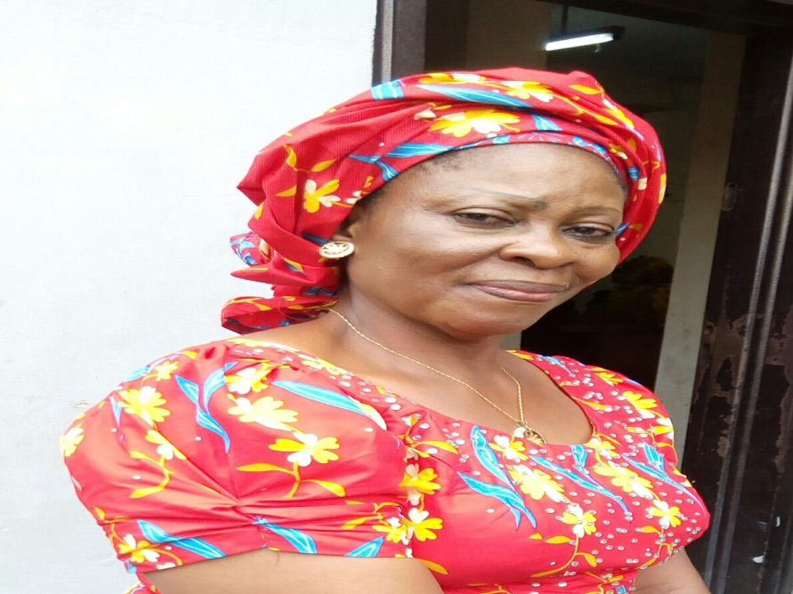

CURRICULUM VITAE
Mercy IjeomaObatta, ACE, Bed, M.Ed (Nigeria)
Biography: Mrs Mercy IjeomaObatta is a Lecturer in the Department of Educational Foundations, University of Nigeria, Nsukka. She was born on the 11th of July 1956. A native of Owerri-North LGA of Imo State, Nigeria. She is Married with 4 children. She holds two master’s degree (M.Ed) in Guidance and Counselling, & Special Education from University of Nigeria, Nsukka (1991 and 1998 respectively). Currently undergoing herDoctor of Philosophy (Ph.D) inUniversity of Nigeria, Nsukka

Date of Birth: 11th July 1956
State of Origin: Imo State
Local Govt. Area: Owerri-North
Marital Status: Married with 4 children
Department: Dept. of Educational Foundations,
University of Nigeria, Nsukka.
Faculty: Education
Designation: Lecturer II
e-mail: mercy.obatta@unn.edu.ng
Phone No: 08035771278
EDUCATION QUALIFICATIONS: DATE
West African School Certificate
West African Examination Council, Lagos 1977

Teachers’ Grade II Certificate
Ministry of Education, Imo State 1979

Associteship Certificate in Education (ACE)
University OF Nigeria, Nsukka 1985

Bachelor of Education (B.Ed) in Guidance and Counselling
University of Nigeria, Nsukka 1991

Master of Education (M.Ed) in Special Education
University of Nigeria, Nsukka 1998

Doctor of Philosophy (Ph.D) (in view)
University of Nigeria, Nsukka

Area of Specialization: Special Education (Learning Disability)

Membership of Professional Bodies:
Member, National Association of Exceptional Children (NAEC)

WORKING EXPERIENCE:
Assistant Headmistress
University Staff School, Nsukka 1983 – 2016

Assistant Lecturer
University of Nigeria, Nsukka 2016 – 2017

Lecturer II
University of Nigeria, Nsukka 2017 – date

PUBLICATION:
- Leonard, T. U., Ubah, J. C., Eze, M.U., Obatta, M. I., Mkpoikanke, S. O., Adaka, T.A. & Philomina, I. E. (2017). Using Total Communication Technique in Teaching Students with Hearing Impairment in Inclusive Classroom in Enugu State – Nigeria: Teachers’ Perspectives and Difficulties. Australian Journal of Basic and Applied Sciences, 11(5) April 2017, Page: 100 – 107.

- Otu, M.C., Udaya, J. C., Ogidi, C. I., Obatta, M. I., Edeh, N. C., & Eduabasi, P. O. (2016). Effect of Cognitive Behavioural Counselling Programme on Smoking Behaviour in a Sample of Nigerian Community dwelling Youths. European Journal of Scientific Research. 142(2), 146 – 152.

- Ubah, J.C., Adaka, T.A., Mkpoikanke, S. O., Obatta, M. I., Edeh, N. C., Ogidi, C. I. & O, G. U. (2017). Parenting Stress in Families with Visual Impaired Child in Nigeria: Implication for Counselling. European Journal of Social Science 54(4), 440-448..

Research Interest: Learning Disability (Dysgraphia)

Responsibilities: Teaching, Examination Administration and Research

Membership of Committees: Faculty Teaching Practice Committee.

