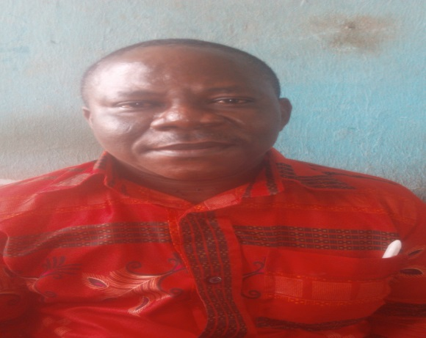

NAME: DR. EZURIKE, CHUKWUEMEKA ALEXADNDER
DEPT: EDUCATIONAL FOUNDATIONS (PSYCHOLOGY)
FACULTY: EDUCATION
DESIGNATION: LECTURER II
E-MAIL: ezurikechukwuemeka@unn.edu.ng
PHONE NO: 07033214079
BIOGRAPHY:
Dr. Ezurike, Chukwuemeka Alexander, a native of Umuehie, Ikperejere in IhitteUboma Local Government Area of Imo State was born on the 24th of July, 1968. He received his formal education in Shomolu Local Government Primary School, Bariga, Lagos State (1979 to 1984), C.M.S. Grammar school III, Bariga, Lagos State (1974 to 1979), Federal School of Arts and Science, Lagos, (1985 to 1986), Lagos State College of Education, Ijanikm, Lagos State where he obtained the Nigerian Certificate in Education in 1991. He was admitted into the University of Nigeria, Nsukka where he was awarded with the Bachelor of Arts in Education BA (ED) English in 1998. He completed his one year compulsory National Youth Service Corps in 1998. He obtained his Masters in Educational Psychology in the University of Nigeria, Nsukka in 2006 and in the year 2017, he was awarded with the most prestigious Honour of Doctor of Philosophy (Ph.D) of the University of Nigeria, Nsukka.
Dr. Ezurike is a Lecturer II in the University of Nigeria, Nsukka, Faculty of Education, Department of Educational Foundations (Psychology). He is a trained Educational Psychologist from the University of Nigeria, Nsukka. He is very resourceful, dynamic with professional experiences, leadership qualities and able to creat conducive classroom environment. He is married and blessed with children.
AREA OF SPECIALIZATION: Educational Psychology.
MEMBERSHIP OF PROFESSIONAL BODIES
ii. Member of the Nigerian council of Educational Psychologist (NCEP)
ii. Member of Teachers Registration Council of Nigeria (TRCN)
WORKING EXPERIENCES:
i. University of Nigeria, Nsukka Continuity Education Centre (part time sandwich) lecturer (1992 to 1995).
ii. Bishop Alex’s Continuing Education Centre, Nsukka, Enugu State: English Teacher (2000 to 2016).

iii. University of Nigeria Nsukka, Enugu State (2017 to Date).

RESPONSIBILITIES
Dr. Ezurike, C. Alex Teaches the following courses;
- Edu: 311 – Personality and social development
- Edu: 312- Educational Psychology II
- Edu: 518- Seminar in Educational Psychology
He is also involved in the semester examination supervisions at the undergraduate and the post graduate levels. He equally attends masters and Ph.D proposals and takes part the marking of the undergraduate and the post graduate scripts. In the faculty of education, Department of Educational Foundations (Psychology unit) of the University of Nigeria, Nsukka, he is a member of the time able and the teaching practice committees. He has the

passion to assist the undergraduate and the post-graduate students in their academic and research works.
Research interest
Family psychodynamicsand child psychology
RESEARCH ARCHIVES/PUBLICATIONS CONFERENCES ATTENDED
LIST OF PUBLICATIONS
Eseadi, C., Ezurike, C. A., Obidoa, M. A. & Ossai, O. V. (2017).Effect of rational emotive behavior therapy on re-offending thoughts of Nigerian prison inmates.The Educational Psychologist. 11 (1), 267-275.
Akabogu, J. U., Ibe, K. C., Omeje, J. C., Ede, M. O., Ezurike, A. C., Ezeh, E. N., Nnamani, A.P. &Ulo-Bethels, A. C. (2018). Social networking and academic adjustment of English Language Students.International Journal of u-and e-Service, Science and Technology, 11 (1), 55-64.
Omeje, J. C., Ede, M. O., Ibe, K. C., Manafa, I., Ezurike, A. C., Ali, R. B., &Ezeh, E. N. (2018). Categories and dangers of social networking among Nigerian in-school adolescents.International Journal of Applied Engineering Research, 13 (6), 3533-3539.
Ezurike, C. A. (2012). Factors affecting the effective implementation of English language curriculum in Senior Secondary Schools in Nigeria. International Journal of Educational Reasearch, 12 (1).
Ezurike, C. A. (2012). Gender differentiations in the selection of Technical skill acquisition subjects in Senior Secondary Schools in Enugu State Nigeria.International Journal of Educational Research, 11 (1).
Ezurike, C. A. (2010). Rethinking teacher quality at higher education level.International Journal of Educational Research, 11 (4).

CONFERENCE ATTENDED AND PAPER PRESENTED
Ossai, O.V., Ezurike, C. A., Ngwoke, D. U.(2017). Parental Support and Socio-cultural belief as a Predictors of School Environment of Upper Basic Students in Nsukka Urban Area of Enugu State.
A paper presented at the Annual National Conference of the Nigerian Council of Educational Psychologists held at University of Abuja Mini Campus Gwawalada on the 17th – 21st October, 2017.

