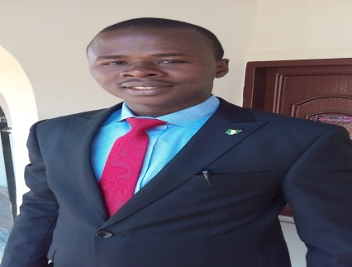
Biography:
Counsellor Effanga, Offiong Asuquo was born on the 10th day of June, 1985 to late Chief (inspector) Asuquo Archibong Effanga and Madam Roseline Effanga of AkwaIkot Effanga village, Akpabuyo L.G.A. of Cross River State, Nigeria.
He began his primary Education in 1991 and obtained the FSLC in 1996, got his SSCE in 2002. In 2015, he obtained his first degree (Second Class Honours, Upper Division) in Guidance and Counselling (Biology option) from Cross River University of Technology, Calabar. He was posted to Nsukka High School, Enugu State for the mandatory NYSC. He is currently undertaking a Masters’ Degree Programme in Guidance and Counselling in the Department of Education Foundations, University of Nigeria, Nsukka.
Counsellor Effanga has held many leadership positions in the Church as Youth President/Adviser, in the Higher Institution as a Class Coordinator and in Student Union Government as the Senate President of Nigeria University Education Students’ Association (NUESA). He has been the Financial Secretary of Student Counselling Association of Nigeria (SCASSON) CRUTECH Chapter. In NYSC he was the CDS president (Cadet-in-chief) of Federal Road Safety Club (NYSC/RSC 9.11), to mention a few.
He started his career in 2017 as a Counselling Psychologist 11 with the University of Nigeria, Nsukka in the Faculty of Education, Department of Educational Foundations. In just few months of dedication to his duties he was nominated to serve as member in the following Departmental committees; The Entrance Board (Admissions committee), Information and Communication Technology(ICT) Committee, Tenders Board (Procurement committee).
“Boyce” as he is fondly called by his peers and family is a born again Christian, who loves God and humanity. He is honest, sincere and treats everyone equally. His philosophy is “Treat Others as Yourself”
Unit: Educational Pyschology
Designation: Counsellor
Department: Educational Foundations
Email: offiong.effanga@unn.edu.ng
Phone: 08117203466

AREA OF SPECIALIZATION: Guidance and Counselling
RESEARCH INTEREST: Human Development with Special Interest in health and safety of the workers in an organization
RESONSIBILITIES:
- Guide students on effective study habit
- Counsel students with vocational, educational and personal-social needs.
- Assist both Staff and Students towards achieving the institutional Webometric goal.
- Training of newly employed Higher Technical Officers in the Department on ICT compliance
- Supply Admission information from admission office
- Serves as screening committee.
AWARDS/COMMENDATIONS:
- Certificate of commendation from the Local Government Inspector NYSC Nsukka Zone.
- Certificate of Excellence from the DEAN Faculty of Education CRUTECH/Patron NUESA.
- Certificate of Honour from Student Counselling Association of Nigeria CRUTECH chapter

PROFESSIONAL AFFILIATION:

INSTITUTION MEMBERSHIP LEVEL

Teachers’ Registration Council of Nigeria member
Chartered Institute of Personnel management of Nigeria Graduate Member
Nigeria institute of safety Professional Graduate Member
PROFESSIONAL CERTIFICATION/QUALIFICATION
INSTITUTIONQUALIFICATION/CERTIFICATION DATE
Mindware Consulting Ltd Human Resource Management (HRM) Certification 2017
Mindware Consulting Ltdhealth, Safety & Environment (HSE):
LEVEL 1 – Risk Management
LEVEL 2 – Industrial Accident Prevention
LEVEL 3 – Environmental Awareness 2017
Ultramod Technologies Diploma in Information Technology 2017

