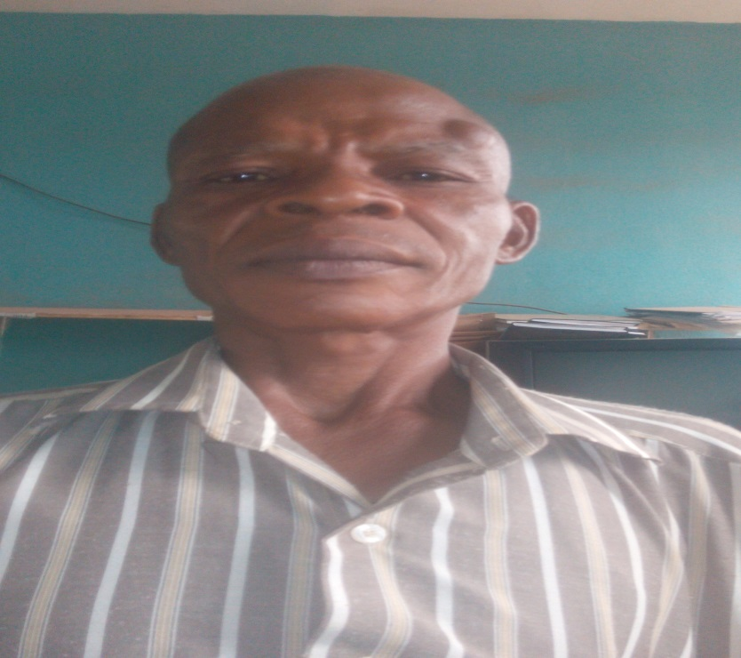
CURRICULUM VITAE
Full Names: UGBOR Cletus Chibuike (Ph. D)
Post Desired: Lecturer 11
Next of Kin: Dr. Mrs Gloria Ngozi Ugbor
Date and Place of Birth: 26/6/67/Aku
State of Origin & L.G.A.: Enugu/Igbo-Etiti
Nationality: Nigerian
Permanent Home Address: Union Primary School AmogwuAku
Phone No: 08135268533
Current Postal Address: Department of Educational Foundations,
University of Nigeria, Nsukka.
Email: cletus.ugbor@unn.edu.ng
Marital Status: Married
Number and Ages of Children: Five(5-08-02, 15-06-04, 15-04-06, 21-10-08, 25-6-2017 respectively)

EDUCATIONAL INSTITUTIONS ATTENDED
University of Nigeria, Nsukka 2010-2017; 2007-2010 & 1989-1993
College of Education Nsugbe 1982-1985
ACADEMIC QUALIFICATIONS
Ph.D in Educational Administration and Planning 2017
Master of Educational Administration and Planning 2010
Bachelor of Education (B.SC, Educational Political Science) 1993
NCE (Economics/Government) 1985
Teachers Registration Council of Nigeria (TRCN) 2009

Professional Body of Membership, (i) Teachers Registration Council of Nigeria (TRCN) - 2009
(ii) Economics Association of Nigeria (ECOAN) -2010
Previous Employers; Nil
Present Employer: University of Nigeria Nsukka
Present Employment Status and Salary:Conuass 3 Step 1
Extra Curricular Activities
Reading, Writing, Teaching and Academic Research
Referees
- Prof. N.O. Ogbonnaya, Associate Dean, School of Post Graduate Studies, University of Nigeria, Nsukka.
- Rev. Dr.L.K. Ejionueme, Department of Educational Foundations, University of Nigeria, Nsukka

- Dr. S.C Ugwuoke , Department of Educational Foundations, University of Nigeria, Nsukka

